**Ideation Phase**

**Define the Problem Statements**

| Date | 31 July 2025 |
| --- | --- |
| Team ID | PNT2025TMID14372 |
| Project Name | **Predictive Pulse: Harnessing Machine Learning for Blood Pressure Analysis** |
| Maximum Marks | 2 Marks |

**Customer Problem Statement Template:**

To define the core problems freelancers face while searching for jobs online, and use those insights to guide the development of Freelance Finder.

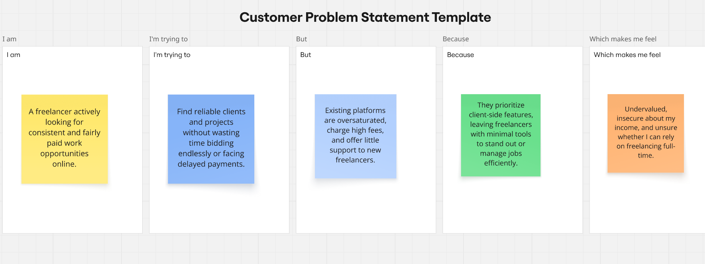

Reference: <https://miro.com/templates/customer-problem-statement/>

| **Problem Statement (PS)** | **I am (Customer)** | **I’m trying to** | **But** |  | **Because** |  | **Which makes me feel** |
| --- | --- | --- | --- | --- | --- | --- | --- |
| **PS-1** | a patient with hypertension. | monitor my blood pressure trends accurately. | manual logs are inconsistent and hard to track. |  | I don’t have real-time analysis or alerts. |  | anxious and uncertain about my health. |
|  |  |  |  |  |  |  |  |
| **PS-2** | a general physician. | predict patient BP anomalies proactively. | current tools only show historical data. |  | they lack intelligent forecasting. |  | underprepared for patient emergencies. |

|  |
| --- |
|  |